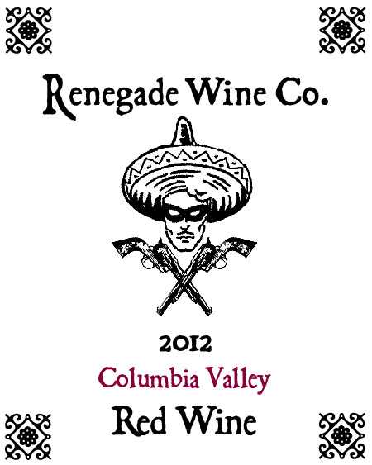

The Renegade Wine Co. is very excited to release the 2012 Renegade Wine Co. Red Wine. And you’ll be glad to know that we made enough this year to last more than 5 months! It is 40% Cabernet Sauvignon, 37% Merlot, 16% Cabernet Franc, 5% Malbec, and 2% Petit Verdot. It certainly drinks like a Washington State Cabernet based blend, with lots of red and black fruits, scents of loamy minerality, and fine grained tannins that are matched with balanced acidity. Like all the Renegade wines, this drinks as well as something twice as expensive. Certainly a candidate to buy by the case! Don’t hesitate, be a Renegade!

